Adam Gincel

BT321

10/29/2017

*I pledge my honor that I have abided by the Stevens Honor System.*

Homework 2

1)

a) 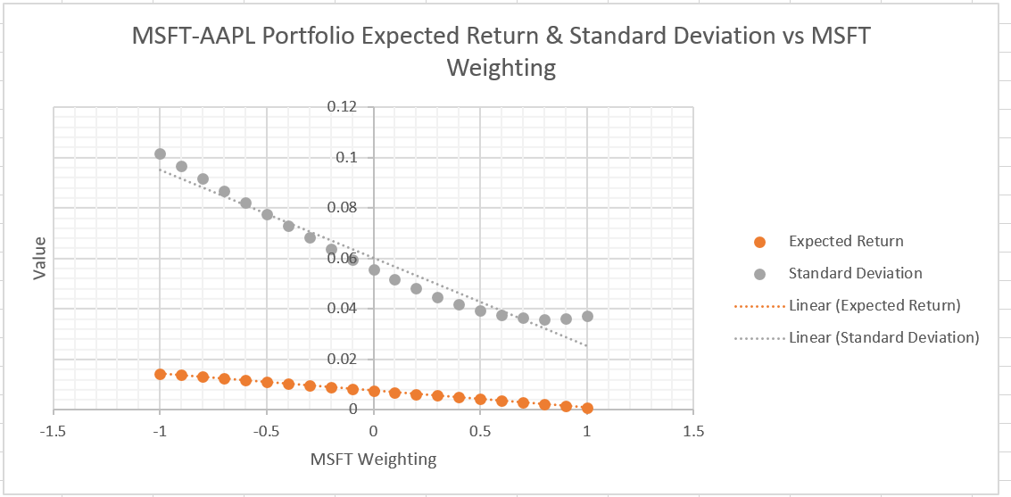

b) 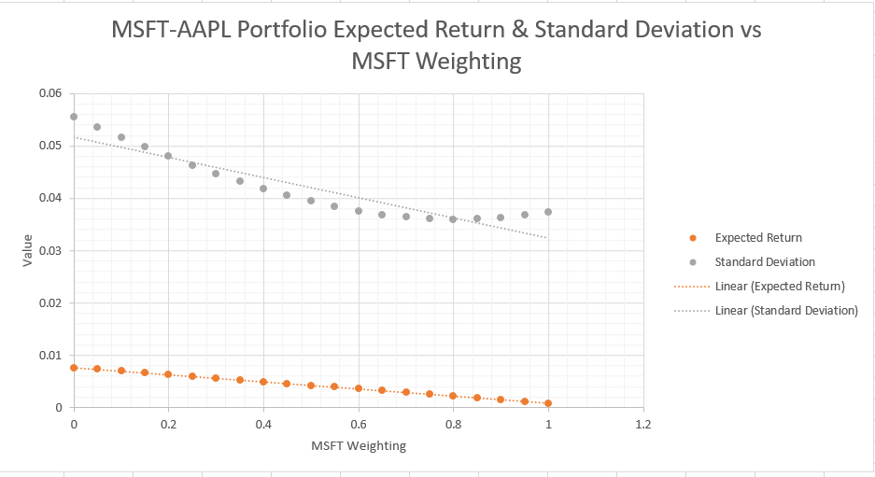

c) Imposing short-sales constraints on a market appears to reduce both overall average expected return, while also reducing standard deviation on the return of the portfolio. It seems to allow for lower risk, lower return portfolios.

d) 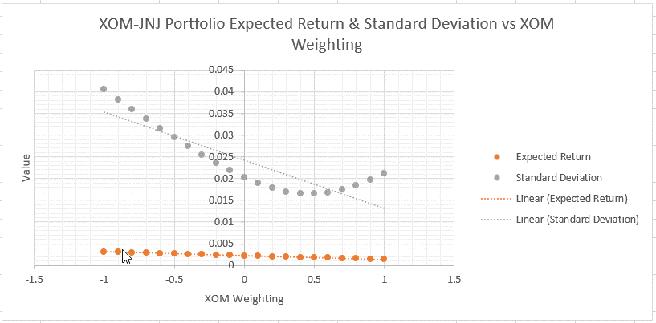

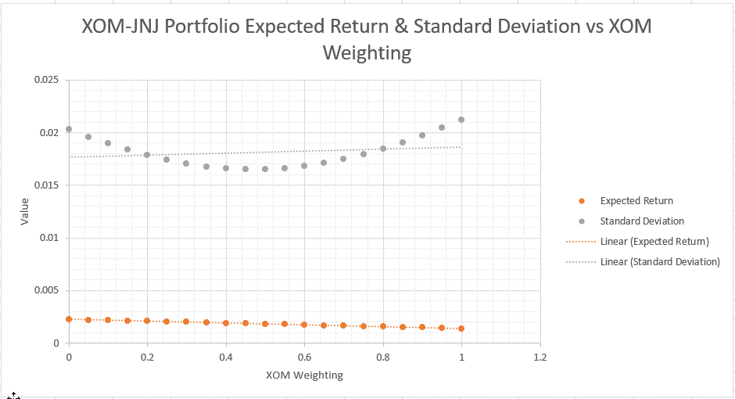  
The graphs of standard deviation in XOM-JNJ seem much more symmetrical than in AAPL-MSFT. This may imply that these two shares are more similar in volatility.

2)

a) 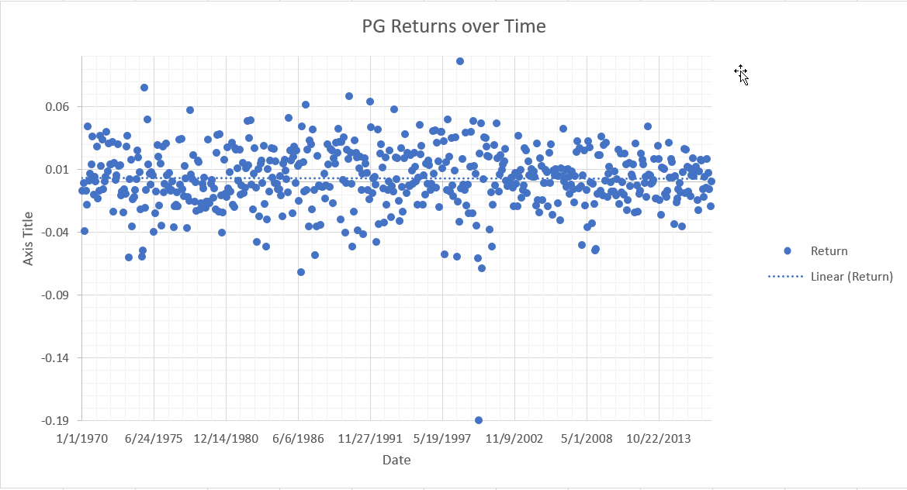

For the time period of 1/1/1970 to 10/29/2017, the overall beta of PG was 0.59997.

b) Beta in 1980s: 0.6979. Beta in 1990s: 0.9044. Beta in 2000s: 0.1768. Beta in 2010s: 0.3968.

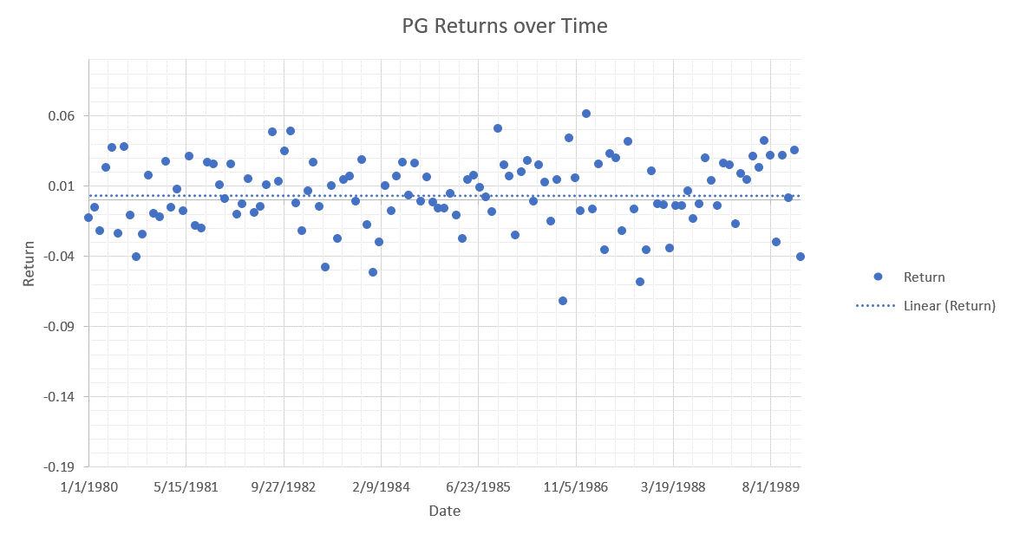

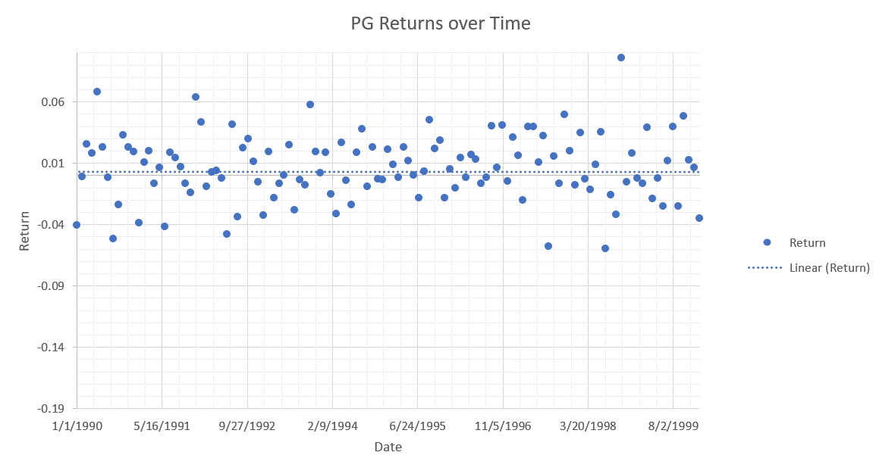

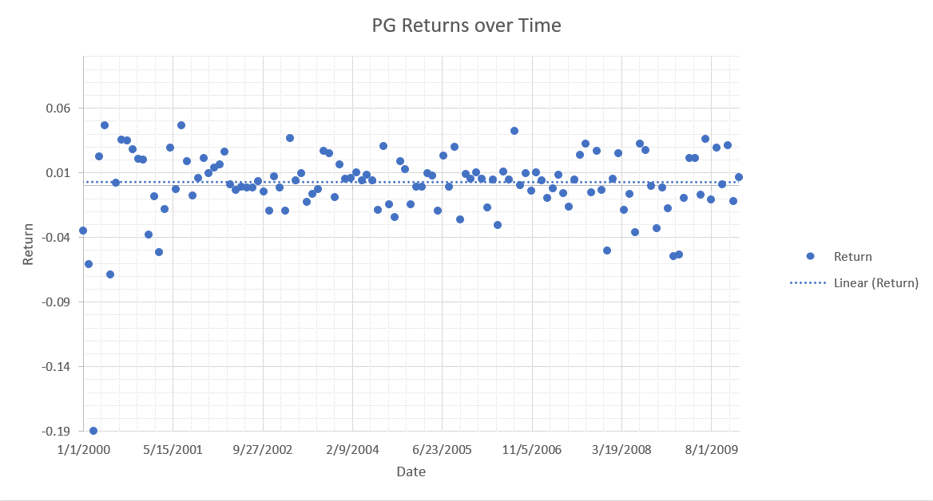

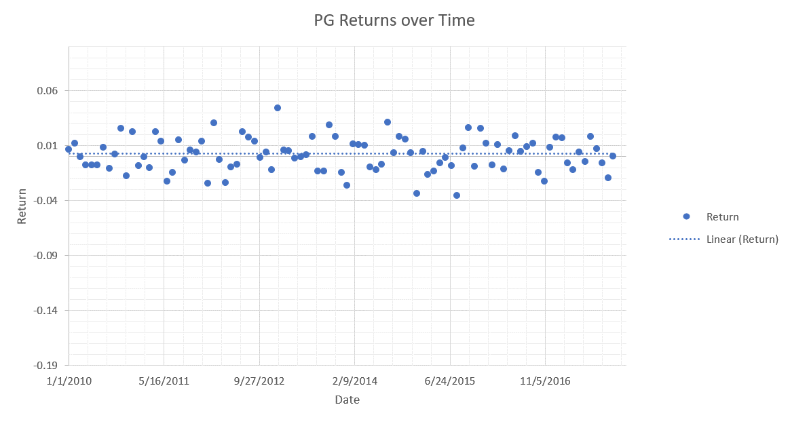

c) By looking at shorter time periods we see that PG did very well in the 1990s, and more poorly by comparison in the 2000s. Even so, looking at the overall Beta for the whole period shows us that PG has been a well performing investment over time.

3)

Ra = Rrf + B*(E(rm) – Rrf)

Stock 1: E(ra) = 12% B = 1.6

Stock 2: E(ra) = 6% B = 0.5

*Using Stock 1 to solve for Rrf*

.12 = Rrf + 1.6(Rm – Rrf) = Rrf + 1.6Rm – 1.6Rrf

.12 – 1.6Rm = -0.6Rrf

Rrf = (0.12 – 1.6Rm) / -0.6

*Using Stock 2 to solve for Rm*

0.06 = Rrf + 0.5(Rm – Rrf) = Rrf + 0.5Rm – 0.5Rrf

Rm = (0.06 – 0.5Rrf) / 0.5

*Solving*

Rrf = (0.12 – 1.6((0.06-0.5Rm) / 0.5)) / -0.6

Rrf = (0.12 – 0.192 + 1.6Rrf) / -0.06

Rrf = (-0.072 + 1.6Rrf) / -0.06

Rrf = 1.2 – 26.67Rrf

**Rrf = 0.0434 = 4.34%**

**Rm =** (0.06 – 0.5(0.0434)) / 0.5 = 0.0766 **= 7.66%**

**Market Risk Premium =** Rm – Rrf **= 3.32%**

4)

I found four ETFs with a decade of historical data behind them: iShares US Real Estate ETF, iShares Cohen & Steers REIT ETF, SPDR Dow Jones REIT EFT, and Vanguard REIT ETF. Conveniently these are four of the largest ETFs on the market, and thus make a good case study.

a)

For the period of January 2007 through October 2017, here are the average monthly and yearly returns for those ETFs:

iShares US Real Estate: Monthly: 0.557% Yearly: 5.952%

iShares Cohen & Steers: Monthly: 0.602% Yearly: 6.062%

SPDR Dow Jones REIT: Monthly: 0.625% Yearly: 6.373%

Vanguard REIT: Monthly: 0.680% Yearly: 7.019%

b)

Betas:

iShares US Real Estate: Beta: 0.478

iShares Cohen & Steers: Beta: 0.419

SPDR Dow Jones REIT: Beta: 0.437

Vanguard REIT: Beta: 0.442

c)

Each of these ETF’s Betas is below 0.5, implying lower volatility. In addition, in their short lifespan thus far they have shown fairly consistent positive growth, even among a very negative market, with Vanguard REIT seeing the highest yearly returns of the bunch. I would feel confident investing in these, though perhaps time will tell; a decade is not the longest time in the world of finance.